Tema 2 – Oprea Sergiu-Daniel 30332

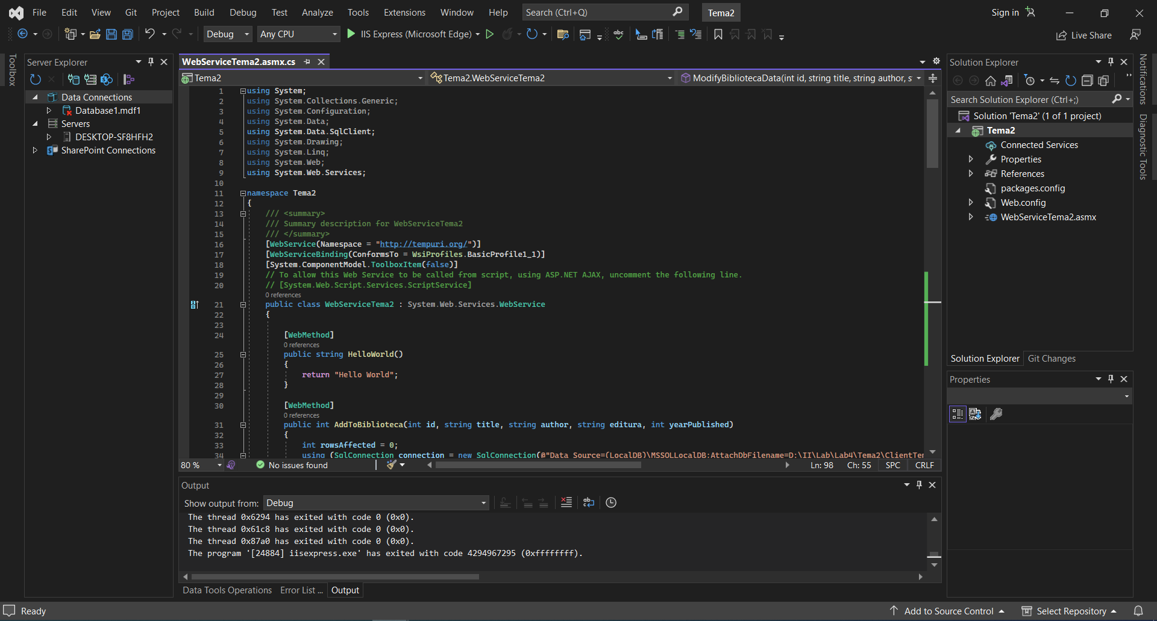Web Service:

Windows Form Client

Adaugare informatii:

Stergere informatii, in functie de titlu si autor:

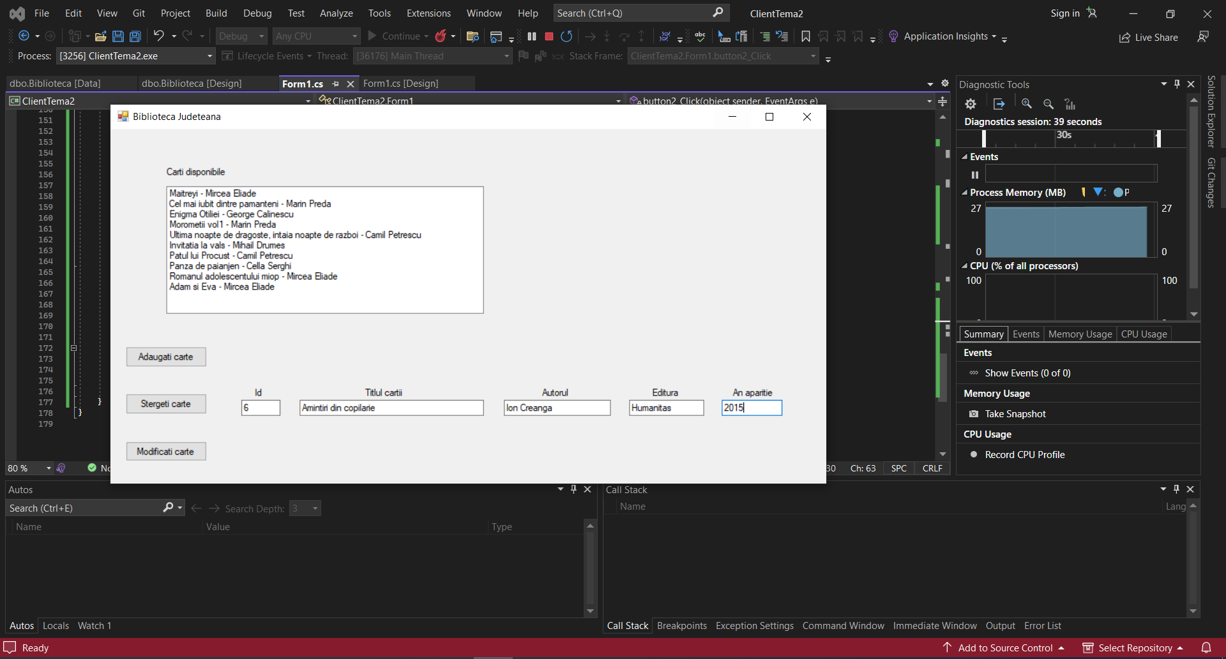Modificare date: modificam cartea cu id = 6

Aplicatia continue imagini pentru fiecare carte, iata alte cateva exemple:

